Profiler tool is used to analyse renders and re-renders. We can see why that component renders and how much time it takes to render.

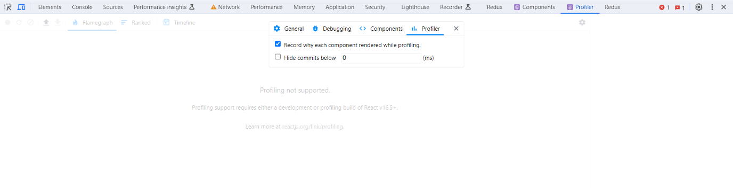

This will give us one of the three reasons that we studied in previous lecture.